 | 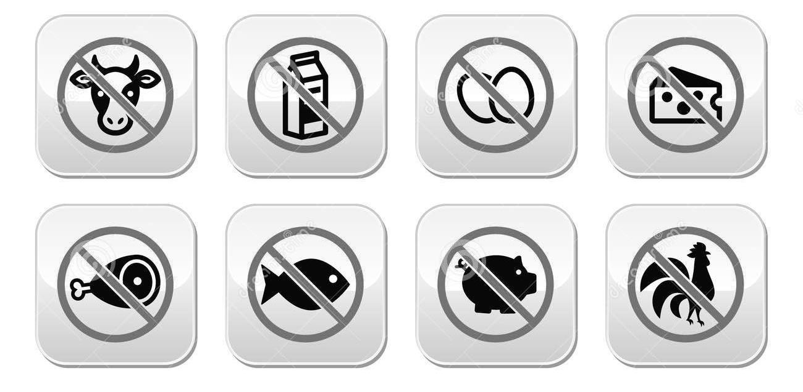
  I am vegan.  I do not eat meat, fish, eggs or dairy.  Can you please make me a meal without any animal products - meat, fish, fowl, eggs, cheese, milk or dairy?  Does this contain meat or fish?  Does this contain eggs?  Does this contain beef or chicken stock?  Does this contain pork or seafood broth? Does this contain gelatin?  Does this contain ghee?  Does this contain cream, milk or cheese?  Does this contain honey?  Does this contain fish sauce, oyster sauce or shrimp paste?  Please leave this ingredient/these ingredients out.  Does this contain fish sauce, oyster sauce or shrimp paste?  Please leave this ingredient out.  Soymilk | Insert translations here!  You can use Google translate (translate.google.com) or another translator.

